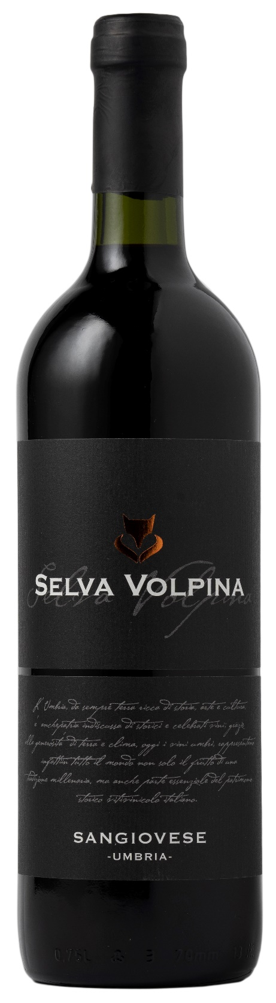
SANGIOVESE UMBRIA – SELVA VOLPINA

Grape: Sangiovese 100%
Alc. Vol.%: 13
Vintage: 2024
Residual sugar g/l: 6,0
Total acidity g/l: 5,0
Region: Umbria
Production zone: Vineyards located in the area of Bastia Umbra (Perugia)
Capacity: 750ml

CHARACTERISTICS

Vinification: In steel tanks at a controlled temperature of 25°C for
10 days of peel maceration
Aging: 8-12 months in steel tanks
Colour: Bright ruby red
Bouquet: Elegant, ethereal with hints of bitter almond
Flavour: Pleasantly dry, smooth and harmonious with a long-lasting finish

SERVING SUGGESTIONS

Best enjoyed with first courses of meat sauces, chicken and red meat, fresh and aged cheese.
Serving temperature 18 °C
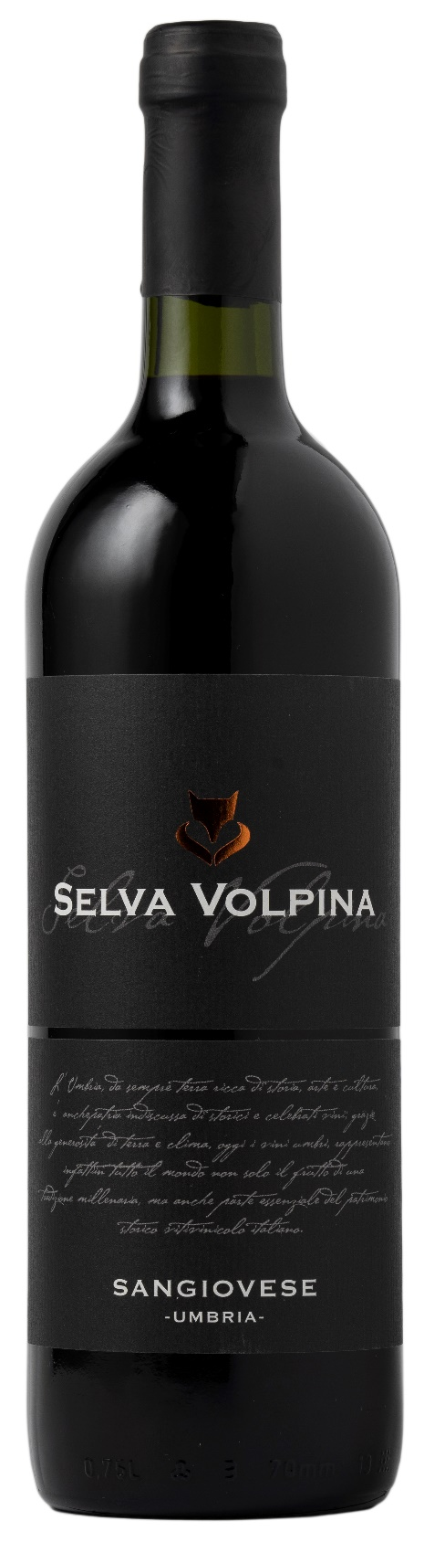
TECHNICAL INFORMATION / PALLETIZING

Size 750ml:
Article Nr. V10005A
GTIN-13 bottle 8017868002581
GTIN-13 carton 8017868002635
Closure Cork/Screwcap
Bottles / carton 6 bottles
Pallet size 80x120cm
Cartons/layer 25
Cartons/pallet 125
Kg/carton 7,2
Kg/pallet 925

Contains sulphites
GMO Free
Revisione 01. 09.05.2024

